Chapter 8, Problem 32.

For the circuit in Fig. 8.80, find v(t) for t > 0.

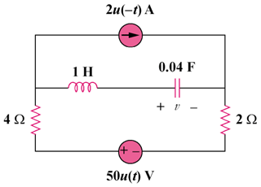

Figure 8.80
For Prob. 8.32.

